HR 2 BREAKDOWN

TEAM: CubeSat Team – Team F

Due Date:
Friday, October 16th, 2020

Here are several images of the current state of the team’s completed system thus far:

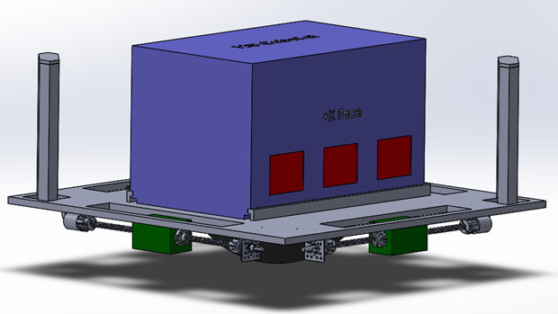
Figure 1. Updated CAD Model

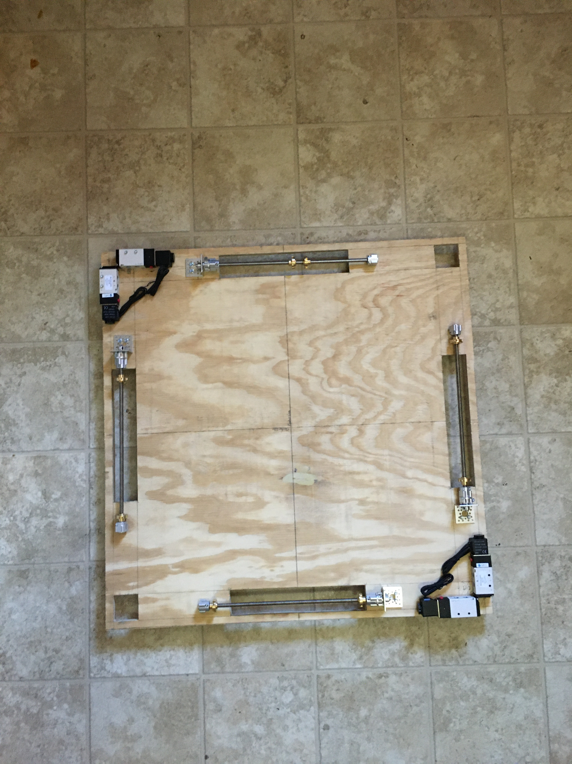
Figure 2. Platform with Rails and Solenoids

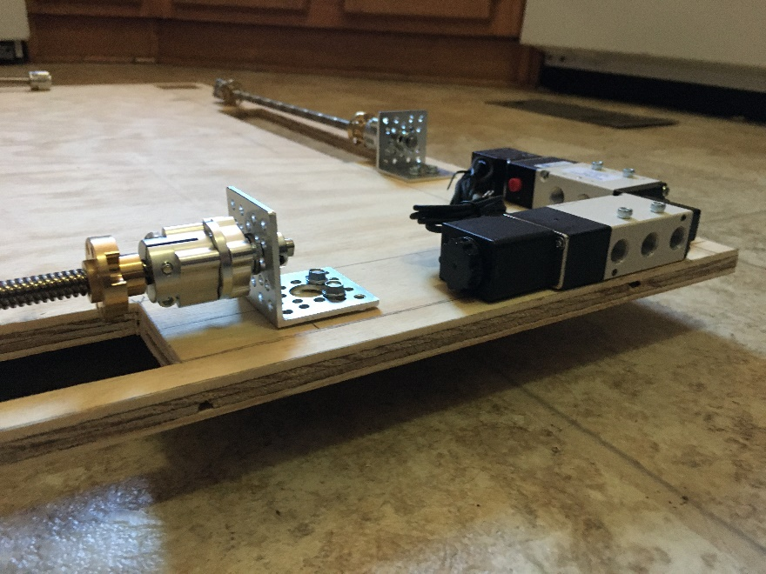
Figure 3. Close-up for Solenoids and Rails
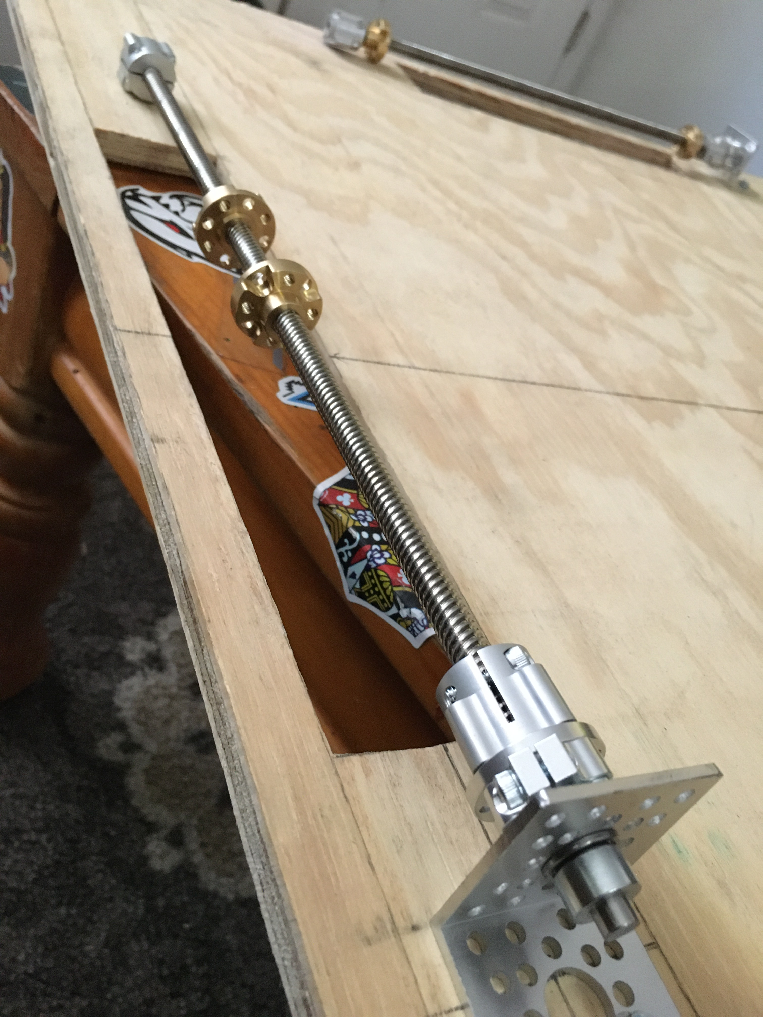
Figure 4. Close-up of Rail Assembly

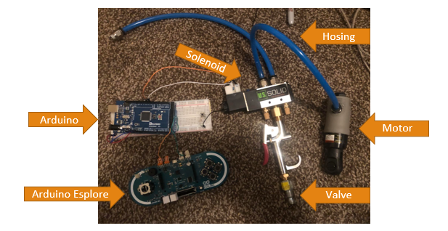
Figure 5. Pneumatic Prototype

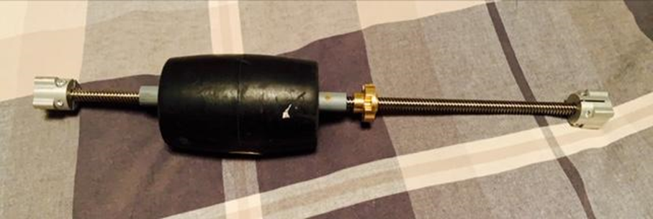
Figure 6. Counterweight Prototype
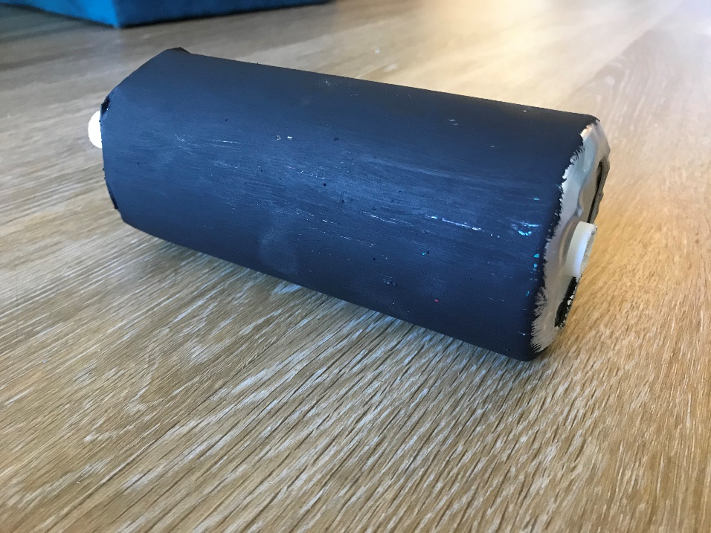
Figure 7. Concrete Molded Counterweight

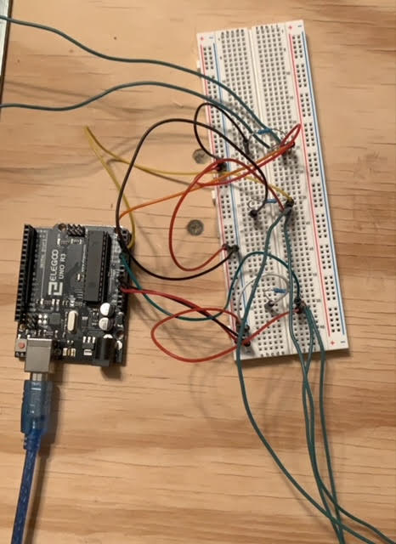
Figure 8. Arduino Force Sensor Set-Up

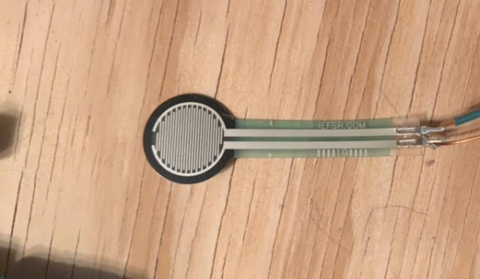
Figure 9. Force Sensor with Soldered Connections

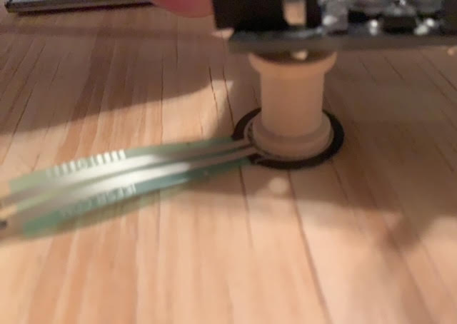
Figure 10. Wooden Spool on Force Sensor

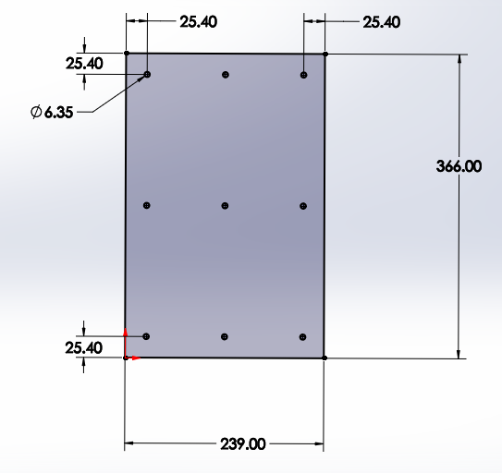
Figure 11. Force Sensor Placement

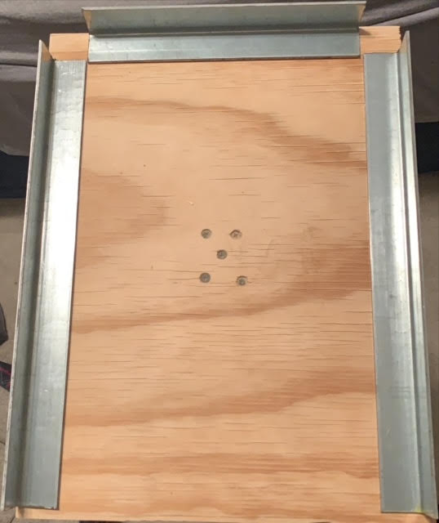
Figure 12. Securing Subsystem Rails

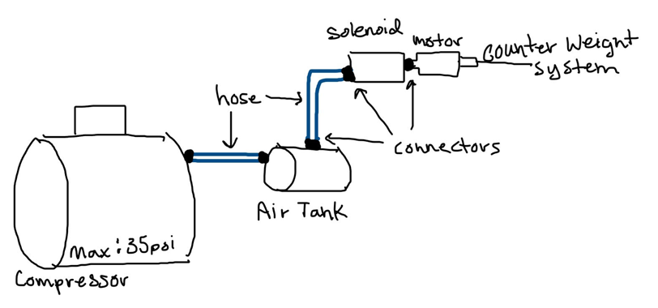
Figure 13. Pneumatic System Plan

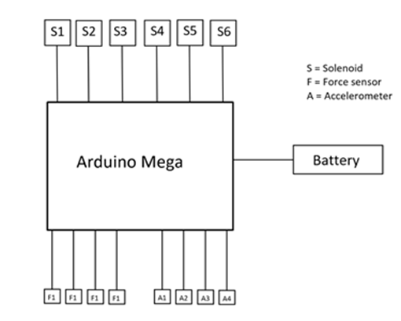
Figure 14. Electrical System Plan

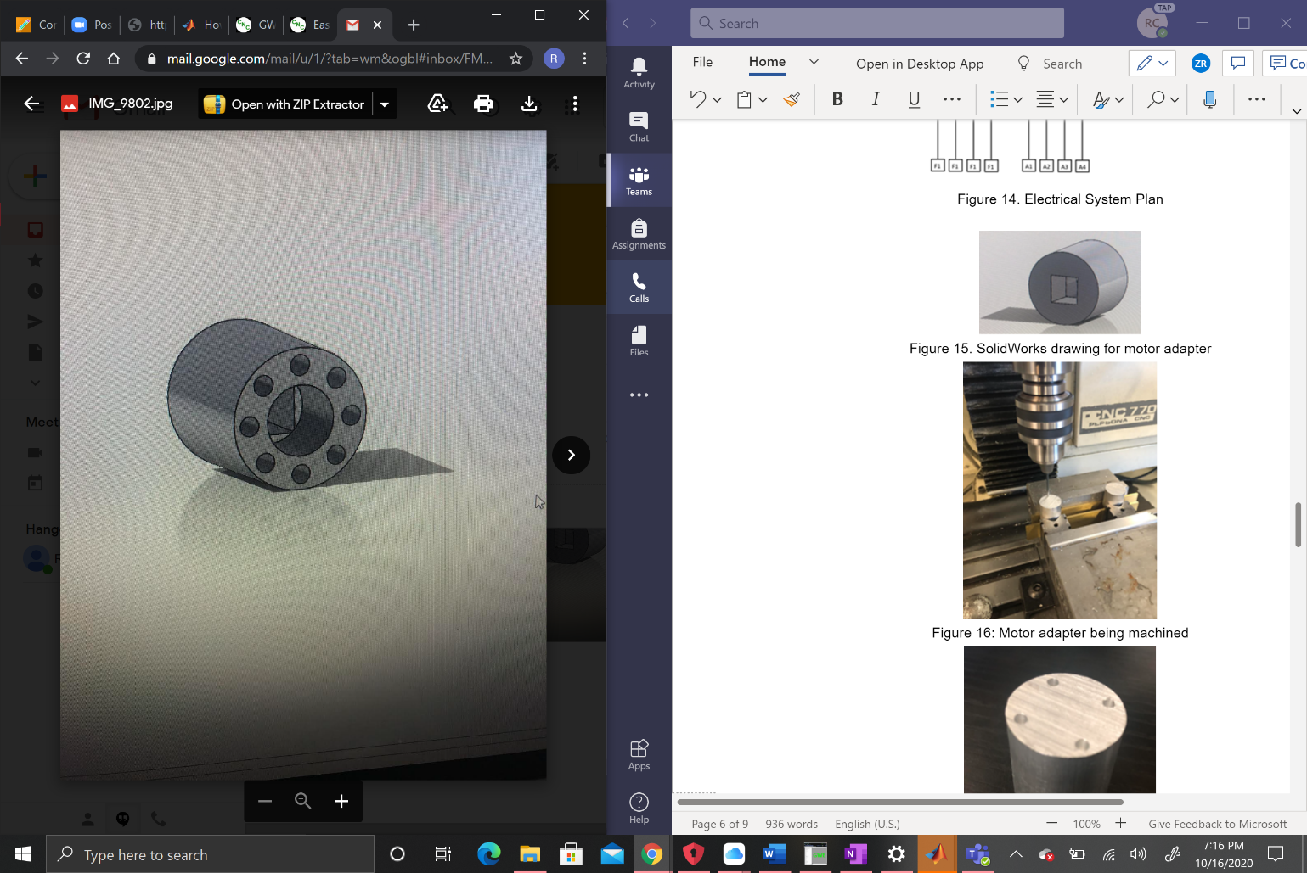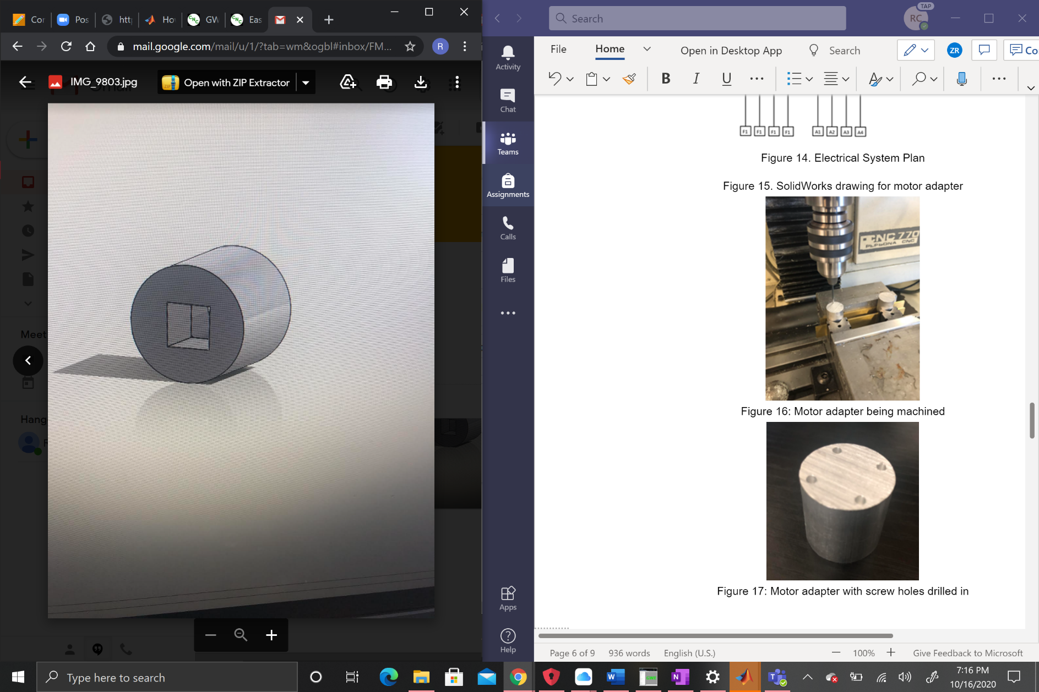
Figure 15. SolidWorks drawing for motor adapter
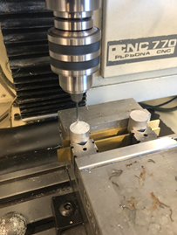
Figure 16: Motor adapter being machined
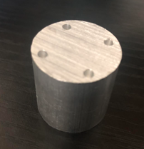
Figure 17: Motor adapter with screw holes drilled in

The following are the Action Items each person completed between Hardware Review 1 and Hardware Review 2:

Team Member: Jacob Belin
Action Item | Date Completed | Result/Proof of Completion
Update CAD Model = V4 | Oct 14 | Increased size of platform, Increased length and width of the cutouts, Added clamping mechanism
Created Platform | Oct 15 | Stenciled in the cutouts we need for the counterweights. Took this to a shop and made cutouts and dimensioned the platform to our specs.
Completed Rail Assemblies | Oct 12 | Used our materials and Richards shaved d-shafts to make complete rail assemblies. These we attached to the cut platform.
Designed Lead Screws | Sept 24 | Met with Richard to design the rail assemblies, select components, and create a bill of materials for the screw.

Team Member: Richard Campos
Action Item | Date Completed | Result/Proof of Completion
Adjust code for accelerometers | September 17 | Code was written that reliably detects z-axis angle of tilt
Design motor adapters | September 24 | Solidworks files in team drive, now a part of Solidworks assembly, see Figure 15
Helped assemble lead screw mechanisms with Jackie | October 5 | Assembled most of lead screw assembly with the exception of d-shafts
Shaved down d-shafts to correct diameter | October 7 | D-shafts now fit in couplers for lead screw mechanisms
Wrote G-code to machine in square hole and screw holes into motor adapter | October 13 | Successful code that machines in screw holes and 3/8” hole for pneumatic motor
Machined in screw holes for motor adapters | October 16 | Holes drilled in as seen in Figure 16 and 17

Team Member: Jacqueline Fonseca
Action Item | Date Completed | Result/Proof of Completion
Developed Pneumatic System Set Up as Team | September 30. | Met with the team to discuss the set-up of the Pneumatic System and create a plan for how it works. Figure 13 shows the plan
Help Set Up Power Screw System | October 5. | Met with the team on Monday to assemble the power screw, and problem solve any problems that we ran into
Developed Code for Counterweight Placement | October 7. | Have a working code, that will take in Pressure Sensor readings and will result in the distance that each of the counterweights need to move.
Calculations for counterweight sizing | October 9. | Ran calculations on what size counterweights should be made for the prototyping model
Molded counterweights | October 15. | Figure 7 shown above. Have six of that size in total, and created one that would weigh a heavier weight in order to test the Pneumatic System

Team Member: Zack Retzlaff
Action Item | Date Completed | Result/Proof of Completion
Developed Circuitry System for Force Sensor Code | September 15th | Initially, the results just showed either low, medium, or high resistance. I developed a code to take in resistance as the independent variable and output force in Newtons. Figures 8 and 9 show the results.
Developed a plan to place the sensors underneath the CubeSat | September 22nd | The team ordered nine FSRs and the plan was to use them to calculate the force distribution of the CubeSat. Therefore, the sensors will be placed at equal lengths as Figure 11 shows above. Wooden spools will be used to concentrate the weight of the CubeSat to more accurately read the CG as shown in Figure 10.
Developed a plan to create the pneumatic subsystem with the team | September 30th | The team met in person to create plans for the pneumatic subsystem and order all needed parts
Created a counterweight prototype | October 3rd | Developed a prototype with a rubber mallet as the counterweight with the lead screw assembly to show the client
Improved Force Sensor Code | October 5th | Made sure the Arduino code read forces in Newtons and determined how to read the force more accurately with wooden spools concentrating the weight of the CubeSat
Researched materials to use for the platform and securing subsystem | October 7th-9th | Worked on my individual analysis to determine which materials to use for our platform and securing system in order to machine these parts in time to put together the final prototype
Worked on machining the rails for our securing subsystem | October 14th | Machined the rails for our securing mechanism. Cut them to the right length so that the team could easily fasten them to the platform next week during assembly

The following are the Action Items for each team member between HR 2 and the Final Product presentation:

Team Member | Action Items | Date Due
Jacob Belin | - Secure as much hardware to platform  - As a Team: Create vertical rails and supports  - As a Team: Test and refine the rail assemblies  - Finish uploading all of the purchasing documentation to Teams  - Create Bill of Materials for the client and presentation | - October 21  - October 23  - November 20  - October 23  - November 20
Richard Campos | - Finish machining in center hole and 3/8” square hole for pneumatic motor  - As a Team: assemble motor and lead screw assembly  - As a Team: integrate different aspects of program into one code  - Do sections of group presentations/reports | - October 21  - October 21  - October 23  - November 20
Jacqueline Fonseca | - Attach counter-weights to power screw  - As a Team: Set up Pneumatic System  - As a Team: Put together entire fixture  - Continue to update Website  - Work on Class Assignments/Presentations/Reports/etc. | 1. October 19.  2. October 20.  3.October 21.  4.November 20
Zack Retzlaff | - Assemble securing subsystem  - As a Team: Put together Pneumatic Subsystem  - As a Team: Assemble Electrical Subsystem  - As a Team: Assemble entire fixture  - Continue to work on meeting minutes, class reports, presentations, CAD models, etc. | - October 19  - October 20  - October 20  - October 21  - November 20

